Energy Efficient Routing in a MANET using Modified OLSR

Shwetha Parthiban, Pallavi Joshi, Indraneel Sanyal

Department of Electrical and Computer Engineering

University of Florida

Gainesville, Florida-32608

*Abstract*— Energy depletion is one of the major problems affecting mobile adhoc networks. The project deals with developing an energy efficient algorithm to increase the network lifetime of a MANET. This is done by modifying the OLSR protocol for calculating the routing table based on the link cost computed from residual energy of the mobile nodes in contrast to the conventional number of hops. Modified OLSR and standard OLSR were simulated under different mobility scenarios in NS-3 to determine the effectiveness of the modified OLSR.

Keywords— MANET, MPR, OLSR, residual energy, network lifetime

# Introduction

Tremendous growth of mobile communications, smartphones, tablets etc. resulted in growth of high-rate multimedia wireless services. D2D communications are highly preferred in 3GPP and LTE to reduce the investment for the infrastructure for this high growth in mobile communications. Mobile Adhoc Networks (MANET) form the basis for D2D communications. MANETs are distributed, self-organized infrastructure-less networks. In MANETs, every node in the network acts a router to take its own decisions and manages its own routing table to route packets between a source and a destination. Due to the mobility of nodes, exchange of control messages between the nodes, overhearing, packet transmissions, energy depletion and thus reduced battery life are major obstacles concerning adhoc networks. Optimized Link State Routing (OLSR) is a proactive minimum-hop routing scheme which involves periodic transmission of HELLO and TC messages by the nodes to convey network information. It is particularly used in dense mobile wireless networks, where delay in transmission is not acceptable. Another peculiarity of OLSR is the broadcasting of control messages to only those nodes that are in its multipoint relay (MPR) set. This reduces additional overhead that are caused by flooding messages throughout the network. OLSR does not take into account the energy depletion of its neighboring nodes and continues to route messages through the minimum hop route. This results in rapid draining of energy of certain nodes that are in commonly used paths causing the network to collapse. In other words, this reduces the network lifetime, which is defined as the time by which the energy of any one node in the network is depleted completely. Energy efficient Modified OLSR implemented in this project takes into account the residual energy of the nodes in determining the link cost and thus changes the way the routing table is computed. The modified OLSR uses the greedy heuristic approach for routing table computation.

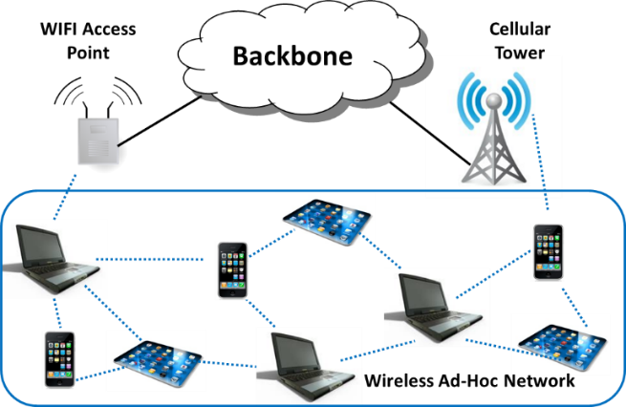

Fig 1.Device to device communication architecture [6]

Figure 1 depicts the architecture of device to device communication involving infrastructure backbone network connecting to the infrastructure-less wireless mobile adhoc network. The mobile adhoc network is responsible for taking its own routing decisions by using various routing protocols.

Figure 2 depicts the general flow of the modified OLSR that was implemented by us.



Figure 2: Program flow of Modified OLSR

# REFERENCE PAPER DESCRIPTION AND ANALYSIS

## Reference paper citation[1]

“Multi-Metric Energy Efficient Routing in Mobile Ad-Hoc Networks”, Authors: Evripidis Paraskevas, Kyriakos Manousakis, Subir Das and John S. Baras, presented at IEEE Military Communication Conference in 2014, Pages-1146-1151.

*Abstract*—Increasing network lifetime by reducing energy consumption across the network is one of the major concerns while designing routing protocols for Mobile Ad-Hoc Networks. In this paper, we investigate the main reasons that lead to energy depletion and we introduce appropriate routing metrics in the routing decision scheme to mitigate their effect and increase the network lifetime. For our routing scheme, we take into consideration multiple layer parameters, such as MAC queue utilization, node degree and residual energy. We integrate our multi-metric routing scheme into OLSR, a standard MANET proactive routing protocol. We evaluate via simulations in NS3 the protocol modifications under a range of different static and mobile scenarios. The main observations are that in static and low mobility scenarios our modified routing protocol leads to a significant increase (5%-20%) in network lifetime compared to standard OLSR and slightly better performance in terms of Packet Delivery Ratio (PDR). *Keywords*-Routing, Energy efficient, OLSR, MANET

## Description

The paper explains the multi-metric scheme used in designing Mobile Adhoc Networks (MANETs). Earlier routing schemes where mostly based on the single scheme like Minimum Drain Rate (MDR) and residual energy[1]. The disadvantage is that these schemes do not consider the whole picture of all the other factors contributing to the network lifetime. OLSR inherits the stability of the link state algorithm, but due to its proactive nature, it has the additional advantage of providing routes as and when required. The routing table of each node gets computed from time to time, thereby providing communication between any two nodes through the lowest distance path computed periodically. The most important concept of OLSR is Multi Point Relay (MPR). The MPR nodes are in 2-hop neighborhood of the source nodes which are selected specifically to forward the topology control packets. The MPR actually multicasts the packets rather than broadcasting of information to unwanted nodes and reducing the overhead as well as the energy required to transport unnecessary packets. Each and every node in OLSR maintains its own MPR selection set.

A modified routing scheme is proposed for the selection of weights in the modified OLSR which inculcates the three most important factors in determining the routing table:

MAC queue utilization: This deals with network congestion. Higher weights should be assigned to congested nodes to ensure that the paths using those nodes are avoided.

Residual energy: Large weights should be assigned to nodes with less residual energy so as to extend the network lifetime.

Node Degree: The traffic should be diverted from nodes with higher degree to reduce traffic congestion due to overhearing.

Now, many metrics of OLSR are adopted using different techniques. Some of them use hop traffic, traffic load, MPR selection, maximal residual energy, energy cost and network lifetime. The chosen metric scheme is a combination of energy cost, residual link lifetime and MAC queueing delay. The weight computation formula is given below:

$${w_{i}=α}_{1}\frac{L_{i}}{L_{max}}+α_{2}\left(1-\frac{E_{i}}{E_{max}}\right)+α_{3}\frac{D_{i}}{D_{max}}$$

Li – number of packets in queue

Ei – residual energy

Di – degree of node

Lmax – maximum queue size

Emax – initial energy of a node

Dmax – number of nodes

The main modification proposed in the paper are in the following two regions:

TC packet:

The basic function in an OLSR is to update the routing table of the nodes periodically. This is done by sending and receiving packets that contains updated information about the neighboring nodes. If these packets were sent just for the purpose of updating the routing table (i.e., containing only cost information) it would be a waste of bandwidth. Thus it was proposed that this information could be included along with the TC packets, thereby reducing the overhead. Hence, these TC packets are made to accommodate the updated weights in them using which the routing table can be updated by the receiving node.

The MPR computation in the algorithm remains the same as that of the conventional OLSR as it covers all the nodes in the 2-hop neighborhood. The computation of the routing table is changed by implementing the new algorithm. As we have to include the link cost rather than the number of hops, the algorithm assigns the weights of the routing quantities described above as weights of the intermediate nodes which are used to calculate the path link cost of the total route.



Figure 3: Link cost calculation for nodes in a network

Figure 3 illustrates the link cost calculation, where the cost of the link from node 1 to 6 is calculated as,

$$C_{16}=1+w_{2}+w_{5}$$

The source weight is always assumed to be 1 and the weight of the destination must not be included in the calculation of link cost. This is because the weights of source and destination will not affect the determination of shortest path.

Greedy-Heuristic algorithm has been used to update the routing table and determine the next destination based on the computed cost.

Algorithm for routing table computation using greedy heuristic method [1]:



Routing table:

The main change in the routing table lies in how the cost is calculated. The OLSR calculates the cost based on the minimum number of hops between the nodes. Even though this method seems better in terms of complexity, it may sometimes mislead the packets to paths that have minimum hops but higher traffic. Thus we compute the paths based on the weights equation shown above. The cost between two nodes A and B is calculated as the sum of the weights of nodes between the nodes A and B and a constant factor of 1 for the node A. The cost at node B is ignored as its power is very less compared to the power consumed at the other nodes. The main advantage of this method is that the traffic gets distributed among all the nodes because the weight of each node is calculated based on the traffic. Thus the method is proved to be more efficient than the standard OLSR.

# SIMULATION DESCRIPTION

## Description of NS-3

NS-3 is a discrete open source simulator used for developing and simulating for modern networking research, development and educational purposes. It is a free software available under the GNU GPLv2 license for the public. NS-3 is well documented using doxygen, easy to debug, and it caters to the needs of the entire simulation workflow, from simulation configuration to trace collection and analysis. Tracing can be enabled using PCAP or ASCII tracing. The trace files can be read using tcpdump or wireshark [3].

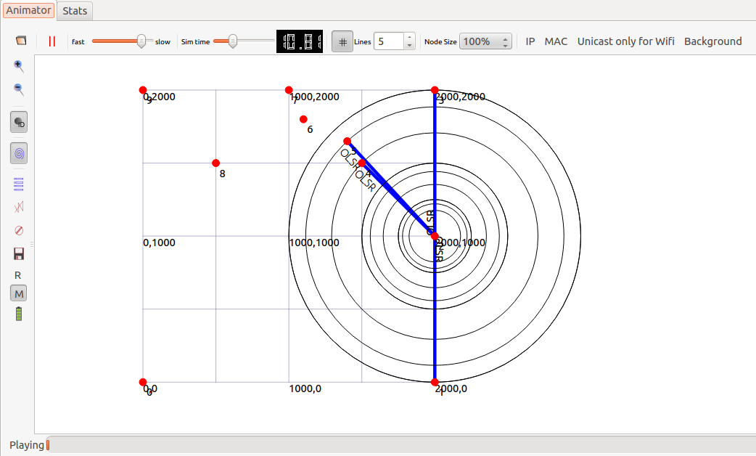

Figure 4: Network Animator

The network animator, which is a part of the ns-3 software, is used to visualize the position of the various nodes, the OLSR packet transmission, the one-hop neighborhood and the routing tables. An example of the network animator at an instance is shown in figure 4.

## Description of the Simulation Design

The simulations were carried out in NS-3. The main parameters of the simulation are given below:

TABLE 1: Simulation Parameters

|  |  |
| --- | --- |
| Number of Nodes | 10 |
| Transmission Power | 5 dBm |
| Initial Energy of nodes | 0.1 J |
| Mobility of nodes | 0 m/s, 2 m/s, 20 m/s |
| Packet Size | 512 B |
| Data Rate | 2048 bps |
| DSSS Rate | 1 Mbps |
| Traffic Start Time | 5 to 6 seconds |
| Total Simulation Time | 100 seconds |

Simulation was carried out for three scenarios based on the mobility of the nodes in the network. Standard and Modified OLSR were implemented in each scenario to determine the network lifetime. The scenarios are described below:

#### Constant Position Nodes

In this scenario the nodes in the wireless network are immobile and are placed at predefined positions in a 2000x2000 m squared area. The energy depletion in the nodes is not as high as that of mobile nodes as the nodes are at fixed positions.

#### Mobile Nodes moving at a speed of 2 m/s

In this scenario the nodes are initially fixed at random positions in a 2000x2000 m squared area. They move randomly with a velocity of 2 m/s. Additional depletion of energy is seen here because of the mobility of the nodes.

#### Mobile Nodes moving at a speed of 20 m/s

This is similar to the scenario described in B except for the velocity of the nodes which is increased to 20 m/s.

## Modifications done to the simulation setup:

A few modifications were done to the original paper. The number of nodes were decreased from 30 to 10 to reduce the number of pointers being used to determine the remaining energy. Transmission power was reduced from 10 dBm to 5 dBm to determine multiple hops in the network. The initial energy was decreased from 7J to 0.1J for faster convergence to zero. This was also the reason to decrease simulation time and traffic start time. Remaining energy of the nodes at each instant was used to determine the link cost and weight at that instant.

## Simulation Results

The main parameters that were used to compare the performance of Standard OLSR and Modified OLSR are the network lifetime and the average residual energy.

#### Average Residual Energy Vs Time:

Figures 5a, 5b and 5c depicts the distribution of average residual energy over time in various mobility scenarios. It can be seen that in the cases of fixed nodes and mobile nodes with a velocity of 20 m/s, the average residual energy of our modified OLSR is the same or in some cases higher than that of standard OLSR.

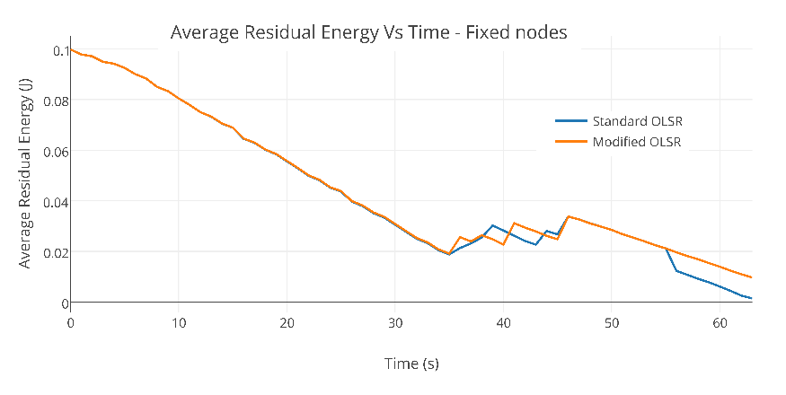

Figure 5a: Average Residual Energy Vs Time for fixed nodes

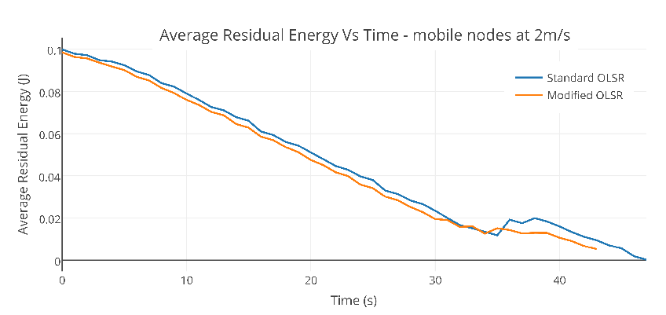

Figure 5b: Average Residual Energy Vs Time for mobile nodes moving at a speed of 2 m/s

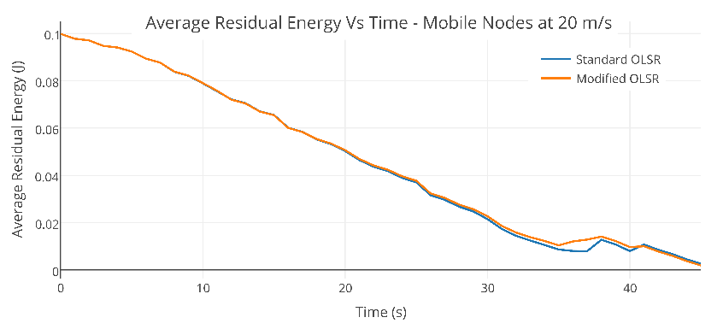

Figure 5c: Average Residual Energy Vs Time for mobile nodes moving at a speed of 20 m/s

However, in the case of mobile nodes with a velocity of 2 m/s, the performance of standard OLSR is efficient than that of our modified OLSR.

#### Network Lifetime

The network lifetime in various scenarios are shown in Table 2.

Table 2: Network Lifetime in various scenarios

|  |  |  |
| --- | --- | --- |
| **Scenarios** | **Standard OLSR** | **Modified OLSR** |
| Fixed Nodes | 35.5201 | 35.4891 |
| Mobile Nodes – 2m/s | 33.6965 | 32.2357 |
| Mobile Nodes – 20m/s | 33.7611 | 33.7013 |

#### Distribution of Node Residual Energy

Figure 6 shows the distribution of node residual energy at the instance of network lifetime for all the nodes tested under different mobility scenarios for standard and our modified OLSR. It can be seen that the residual energy of the nodes are mostly higher in the case of our modified OLSR even though its overall network lifetime is a little lesser than that of standard OLSR as seen in Table 2. This is because network lifetime is measured when any one of the nodes’ energy becomes zero. However the average residual energy of the nodes is comparatively higher in the case of our modified OLSR. This signifies that the overall network lasts longer in the case of our modified OLSR.

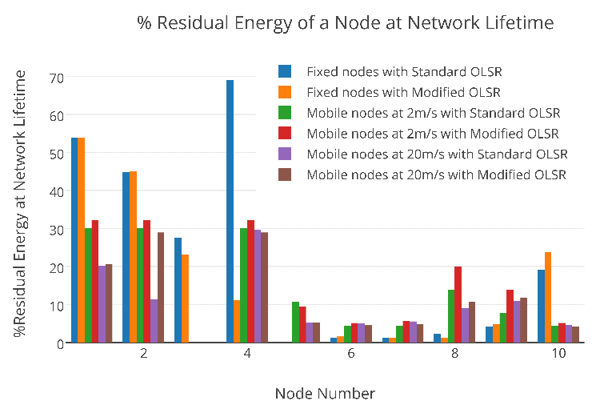

Figure 6: Distribution of % Residual Energy in the nodes

## Comparison of Results:

The method described in the paper showed a significant increase in network lifetime. It also showed that half of the nodes had 30 – 70% residual energy at the end of the simulation time. Both these quantities were lesser in our simulation. Our model showed a network lifetime quite similar to the standard OLSR and most of the nodes maintained 10 – 70% of their energy. This is because the paper suggests the use of Node Degree and MAC queue utilization factors in addition to the residual energy factor used.

# CONCLUSION

## Discussions on NS-3

NS-3 is mainly based on C++ syntax and methods. However, several inbuilt classes and files in NS-3 make it difficult to understand initially. After getting a grip on the existing libraries, one gets a certain command over NS-3.

## Difficulties in implementation

A major doubt that daunted us was the concept of source and sink. After implementing the OLSR initially, we were unable to see multiple hops using Network Animator. It was later resolved by a careful observation of the routing tables corresponding to each node and by decreasing the transmission power and increasing the distance between the nodes so that all nodes are not a distance within one hop of each other. Finding residual energy was yet another task as we needed to use as many pointers as the number of nodes in the network to access its residual energy from the basic energy source class. It was difficult to pass the residual energy and weights to the function for routing table computation due to constraints introduced by the highly complex MakeCallback function, which was avoided by using the BasicEnergySource smart pointer in olsr-routing-protocol.cc and by declaring the weights as a global variable.

## Division of labor

The project was a joint effort of all the team members. This is because of various factors. Installation and setup took time which was not anticipated. The vast ns-3 libraries and the implementation of sample programs were very complex and it required the participation of all the team members at all times. As debugging was difficult and the members had proficiency in different parts of C++, it was not possible for any one person to debug an entire module. Our project involved three modules which were highly dependent on each other. One could not progress with the implementation of the next module until the results from the previous ones were obtained. This made division of jobs very difficult. Hence we met regularly and discussed and implemented the project together.

##### Acknowledgment

We would like to thank Dr. Janice McNair for providing us with the motivation and guidance to go about the project and Mr. Gokul Bhat for guiding us and clarifying our doubts regarding the working of NS-3.

##### References

1. Evripidis Paraskevas∗, Kyriakos Manousakis, Subir Das and John S. Baras “Multi-Metric Energy Efficient Routing in Mobile Ad-Hoc Networks”, 2014 IEEE Military Communications Conference.
2. Description of OLSR protocol- RFC 3626- https://www.ietf.org/rfc/rfc3626.txt
3. www.olsr.org

NS Documentation- https://www.nsnam.org/

1. Gustavo J.A.M. Carneiro- https://www.nsnam.org/tutorials/NS-3-LABMEETING-1.pdf
2. NS-3 Description-

http://www.iitg.ernet.in/cse/rana2013/material/day5part2/presentation.pdf

1. Arash Asadi, Qing Wang and and Vincenzo Mancuso, “A Survey on Device-to-Device Communication in Cellular Networks”, April 2014, Pages: 1801 – 1819.
2. Daquan Feng, Lu Lu, Yi Yuan-Wu, Geoffrey Ye Li, Shaoqian Li, and Gang Feng, “Device-to-Device Communications in Cellular Networks”, April 2014, Pages: 49 – 55
3. http://www.cs.sjtu.edu.cn/~fwu/res/fig-NSFC11.png
4. Abdalla, G.M.T., Abu-Rgheff, M.A.and Senouci,S.M ,” Current trends in vehicular ad-hoc networks”, IEEE Global Information Infrastructure Symposium, 2007, Pages: 1−7
5. Sensor Networks: Wireless Communications and Networking, Vijay K.Garg
6. http://www.ics.uci.edu/~keldefra/manet.html
7. http://www.ericsson.com/research-blog/5g/device-device-communications/
8. Ash Mohammed Abbas, Oivind Kure, “Quality of service in mobile Adhoc Networks: A survey”, International Journal Adhoc and Ubiquitous computing